This document is written to give a general introduction to the real robotic experiments. This code requires a MATLAB with a Simulink and Real time Target systems libraries.

The main model file is “RobotControl1_640_480.slx”. To run this model, first the Simulink model must be ready to run. Later, open the Simulink Real time explorer by using “slrtexplr” command in MATLAB. Using this interface, the model can be sent to the target machine (robotic vehicle) and it can be run remotely from the host machine. Here is the picture of “Simulink Real time explorer”.

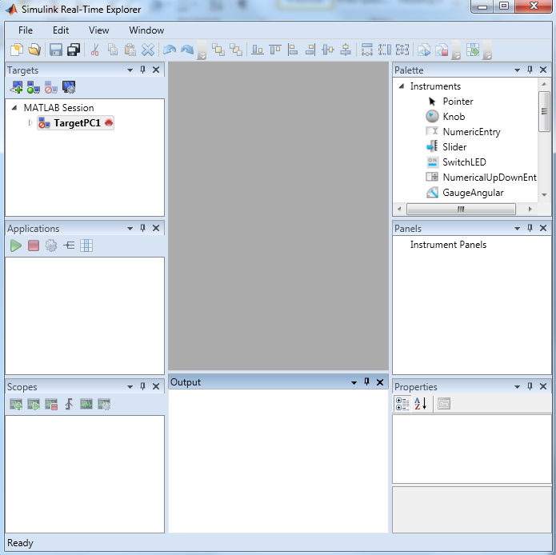

In the model file (RobotControl1_640_480.slx), Open-loop control block includes the robot control source codes.

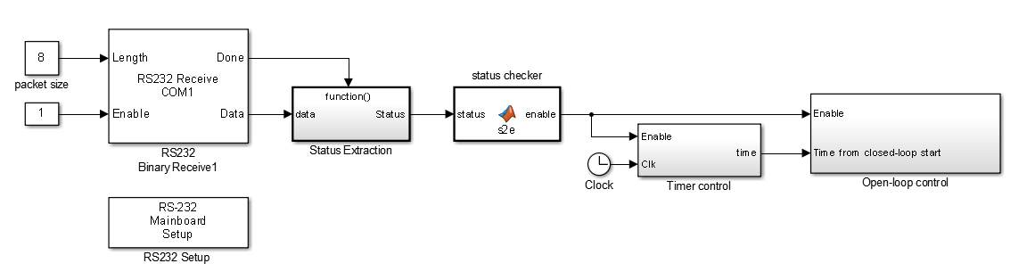

The inside of that block is given below. In this block, Vision System includes the Mirage calculations. To make any modification in Mirage, please go into the “Vision system” block.

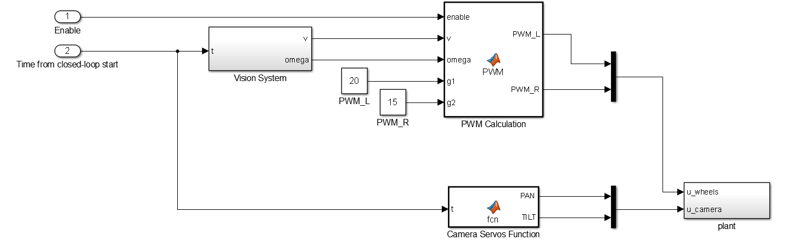

Any changes regarding Mirage must be made in the “Pose Estimation Block”  
